Assignment-4 :

1.Connect a USB webcam to your computer, install any required drivers, and verify that the webcam works by opening the default camera app and capturing a photo.

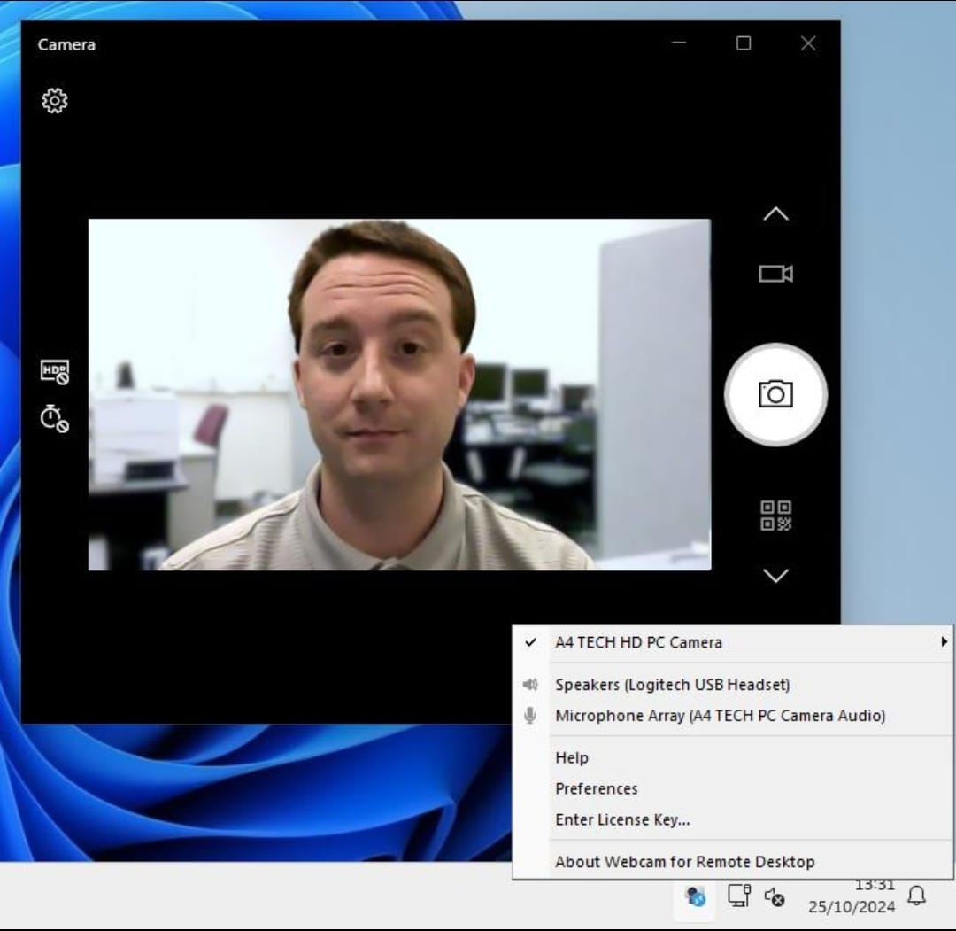

2.Set up a local printer (USB or network), install the correct driver, and print a test page to confirm successful installation.
----
- Connect the printer
- For a USB printer, connect the USB cable between the printer and computer.
- For a network printer, connect the printer to the same Wi-Fi/network as the computer.
- Turn on the printer
- Switch on the printer and make sure there is paper and ink/toner.
- Install the printer driver
- Open Settings → Bluetooth & devices → Printers & scanners.
- Click Add device.
- Windows may automatically detect and install the correct driver.
- If required, download and install the driver for the exact printer model from the manufacturer's website.
- Check the printer
- Go to Printers & scanners and confirm that your printer appears.
- Select the printer and check that it shows as Ready/Online.
- Print a test page
- Open the printer's settings/properties.
- Select Print Test Page.
- Wait for the printer to print the page.
- Verify installation
- Check the printed test page.
- If it prints correctly, the printer, connection, and driver are working successfully.

3. Simulate a connectivity issue by unplugging the printer's USB cable, then use Windows Device Manager to identify and resolve the 'printer not detected' problem.<br><br><em><strong>Hint:</strong> Check for error icons and use the 'Scan for hardware changes' option after reconnecting.</em>
-- Disconnect the printer
Turn on the printer.
Unplug the USB cable connecting the printer to the computer.
Windows may now show that the printer is unavailable or not detected.
-- Open Device Manager
Press Windows + X.
Select Device Manager.
Expand Printers, Print queues, or Universal Serial Bus controllers.
-- Check for an error
Look for the printer or an Unknown device.
A yellow warning icon (⚠️) indicates a possible driver or hardware problem.
-- Reconnect the printer
Plug the USB cable back into the computer.
Make sure the printer is powered on.
-- Scan for hardware changes
In Device Manager, click Action → Scan for hardware changes.
Windows should detect the connected printer again.
-- Update the driver if necessary
Right-click the printer/unknown device.
Select Update driver → Search automatically for drivers.
If the driver is corrupted, uninstall the device and reconnect the printer so Windows can reinstall it.
-- Verify the solution
Open Settings → Bluetooth & devices → Printers & scanners.
Confirm that the printer appears.
Print a test page to verify that the problem has been resolved.

4. A user reports that their webcam video is not displaying in Zoom, but it works in the default camera app. Troubleshoot and resolve the issue so the webcam works in both applications.<br><br><em><strong>Hint:</strong> Check if another app is using the webcam or if Zoom permissions are enabled.</em>
- Test the webcam
- Open the Windows Camera app.
- Confirm that the webcam displays video.
- Since it works in Camera, the webcam hardware and basic driver are working.
- Close other apps using the webcam
- Close the Camera app and any other application that may be using the webcam.
- Restart Zoom and test the camera again.
- Only one application may sometimes be able to access the webcam at a time.
- Check Zoom camera settings
- Open Zoom.
- Go to Settings → Video.
- Under Camera, select the correct USB webcam.
- Check whether the video preview appears.
- Check Windows camera permissions
- Go to Settings → Privacy & security → Camera.
- Turn on Camera access.
- Turn on Let apps access your camera.
- Make sure desktop apps are allowed to access the camera.
- Check the webcam driver
- Press Windows + X → Device Manager.
- Expand Cameras.
- Right-click the webcam → Update driver.
- Select Search automatically for drivers.
- Restart Zoom
- Completely close Zoom.
- Reopen it and select the webcam under Settings → Video.

- Verify the solution
- Start a Zoom meeting and check the video.
- If the webcam displays correctly in both Windows Camera and Zoom, the problem is resolved.

